Hands on 1

**Spring Data JPA - Quick Example** 

**application.properties :**

spring.application.name=orm-learn

# Spring Framework and application log

logging.level.org.springframework=info

logging.level.com.cognizant=debug

# Hibernate logs for displaying executed SQL, input and output

logging.level.org.hibernate.SQL=trace

logging.level.org.hibernate.type.descriptor.sql=trace

# Log pattern

logging.pattern.console=%d{dd-MM-yy} %d{HH:mm:ss.SSS} %-20.20thread %5p %-25.25logger**{25}** %25M %4L %m%n

# Database configuration

spring.datasource.driver-class-name=com.mysql.cj.jdbc.Driver

spring.datasource.url=jdbc:mysql://localhost:3306/ormlearn

spring.datasource.username=root

spring.datasource.password=root

# Hibernate configuration

spring.jpa.hibernate.ddl-auto=validate

spring.jpa.properties.hibernate.dialect=org.hibernate.dialect.MySQLDialect

spring.jpa.hibernate.ddl-auto=create

**Country.java**

package com.cognizant.orm_learn.model;

import jakarta.persistence.Entity;

import jakarta.persistence.Id;

*@Entity*

public class Country {

*@Id*

private String code;

private String name;

public Country() {

}

public Country(String code, String name) {

this.code = code;

this.name = name;

}

public String getCode() {

return code;

}

public void setCode(String code) {

this.code = code;

}

public String getName() {

return name;

}

public void setName(String name) {

this.name = name;

}

*@Override*

public String toString() {

return "Country [code=" + code + ", name=" + name + "]";

}

}

**CountryRepository.java**

package com.cognizant.orm_learn.repository;

import org.springframework.data.jpa.repository.JpaRepository;

import org.springframework.stereotype.Repository;

import com.cognizant.orm_learn.model.Country;

@Repository

public interface CountryRepository extends JpaRepository<Country, String> {

}

**CountryService.java**

package com.cognizant.orm_learn.service;

import java.util.List;

import org.springframework.beans.factory.annotation.Autowired;

import org.springframework.stereotype.Service;

import org.springframework.transaction.annotation.Transactional;

import com.cognizant.orm_learn.model.Country;

import com.cognizant.orm_learn.repository.CountryRepository;

@Service

public class CountryService {

@Autowired

private CountryRepository countryRepository;

@Transactional

public List<Country> getAllCountries() {

return countryRepository.findAll();

}

}

**OrmLearnApplication.java**

package com.cognizant.orm_learn;

import java.util.List;

import org.springframework.boot.CommandLineRunner;

import org.springframework.boot.SpringApplication;

import org.springframework.boot.autoconfigure.SpringBootApplication;

import org.springframework.context.annotation.Bean;

import com.cognizant.orm_learn.model.Country;

import com.cognizant.orm_learn.repository.CountryRepository;

*@SpringBootApplication*

public class OrmLearnApplication {

public static void main(String[] args) {

SpringApplication.*run*(OrmLearnApplication.class, args);

System.***out***.println("Inside main");

}

*@Bean*

CommandLineRunner run(CountryRepository countryRepository) {

return args -> {

Country india = new Country("IND", "India");

Country usa = new Country("USA", "United States of Amercia");

countryRepository.save(india);

countryRepository.save(usa);

System.***out***.println("Countries inserted successfully!");

*testGetAllCountries*(countryRepository);

};

}

public static void testGetAllCountries(CountryRepository countryRepository) {

System.***out***.println("Start");

List<Country> countries = countryRepository.findAll();

System.***out***.println("countries=" + countries);

System.***out***.println("End");

}

}

**OUTPUT:**

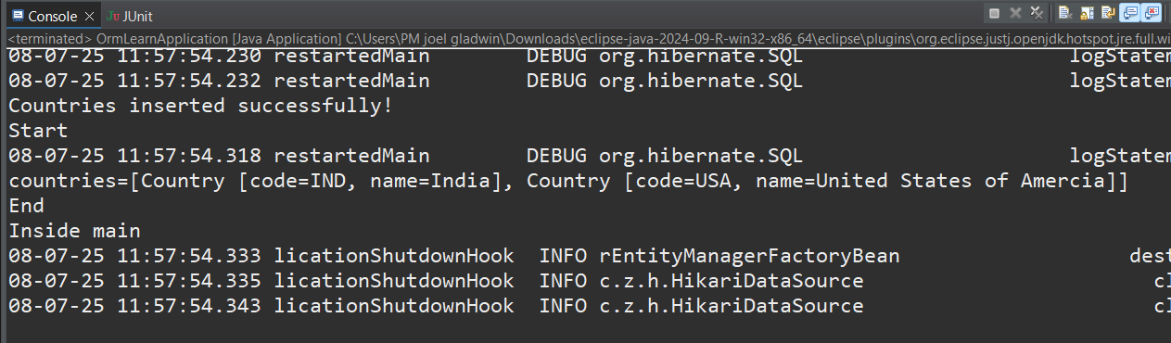

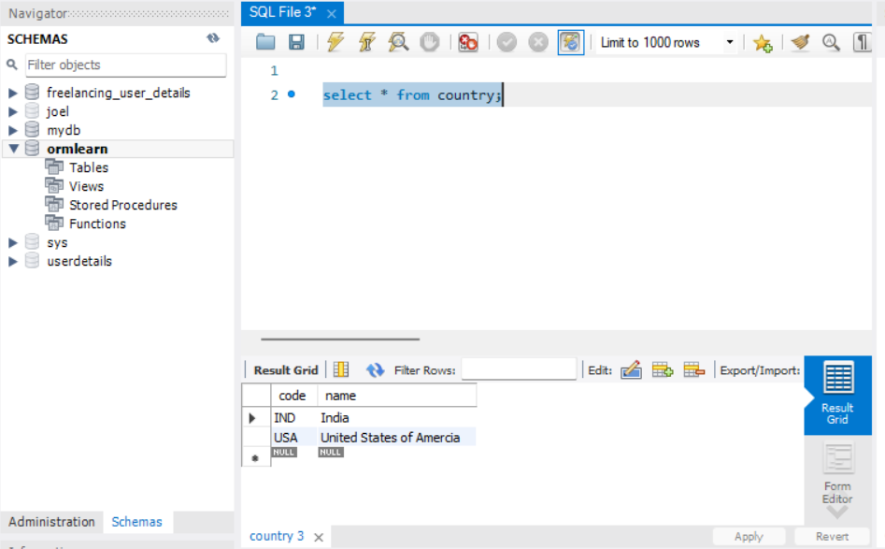

**Hands on 4**

**Difference between JPA, Hibernate and Spring Data JPA**

**JPA:**

**Jpa provide rules and annotations – eg -@Entity etc…**

@PersistenceContext

private EntityManager entityManager;

@Transactional

public void addEmployee(Employee employee) {

entityManager.persist(employee);

}

**HIBERNATE:**

**Hibernate is used for orm mapping – Object Relation Mapping**

public Integer addEmployee(Employee employee) {

Session session = factory.openSession();

Transaction tx = null;

Integer employeeID = null;

try {

tx = session.beginTransaction();

employeeID = (Integer) session.save(employee);

tx.commit();

} catch (HibernateException e) {

if (tx != null) tx.rollback();

e.printStackTrace();

} finally {

session.close();

}

return employeeID;

}

**Spring Data JPA:**

**EmployeeRepository.java**

public interface EmployeeRepository extends JpaRepository<Employee, Integer> {}

**EmployeeService.java**

@Autowired

private EmployeeRepository employeeRepository;

@Transactional

public void addEmployee(Employee employee) {

employeeRepository.save(employee);

}

**Hands on 5**

**Implement services for managing Country**

**Country.java**

package com.cognizant.orm_learn.model;

import jakarta.persistence.Column;

import jakarta.persistence.Entity;

import jakarta.persistence.Id;

import jakarta.persistence.Table;

*@Entity*

*@Table*(name = "country")

public class Country {

*@Id*

*@Column*(name = "co_code")

private String code;

*@Column*(name = "co_name")

private String name;

// Constructors

public Country() {}

public Country(String code, String name) {

this.code = code;

this.name = name;

}

// Getters and Setters

public String getCode() { return code; }

public void setCode(String code) { this.code = code; }

public String getName() { return name; }

public void setName(String name) { this.name = name; }

*@Override*

public String toString() {

return "Country [code=" + code + ", name=" + name + "]";

}

}

**CountryRepository.java**

package com.cognizant.orm_learn.repository;

import java.util.List;

import org.springframework.data.jpa.repository.JpaRepository;

import org.springframework.stereotype.Repository;

import com.cognizant.orm_learn.model.Country;

@Repository

public interface CountryRepository extends JpaRepository<Country, String> {

List<Country> findByNameContainingIgnoreCase(String name);

}

**CountryService.java**

package com.cognizant.orm_learn.service;

import java.util.List;

import org.springframework.beans.factory.annotation.Autowired;

import org.springframework.stereotype.Service;

import org.springframework.transaction.annotation.Transactional;

import com.cognizant.orm_learn.model.Country;

import com.cognizant.orm_learn.repository.CountryRepository;

*@Service*

public class CountryService {

*@Autowired*

private CountryRepository countryRepository;

public Country getCountryByCode(String code) {

return countryRepository.findById(code).orElse(null);

}

public void addCountry(Country country) {

countryRepository.save(country);

}

public void updateCountry(String code, Country newData) {

if (countryRepository.existsById(code)) {

newData.setCode(code); // ensure code remains the same

countryRepository.save(newData);

}

}

public void deleteCountry(String code) {

countryRepository.deleteById(code);

}

public List<Country> findCountriesByName(String partialName) {

return countryRepository.findByNameContainingIgnoreCase(partialName);

}

}

**OUTPUT:**

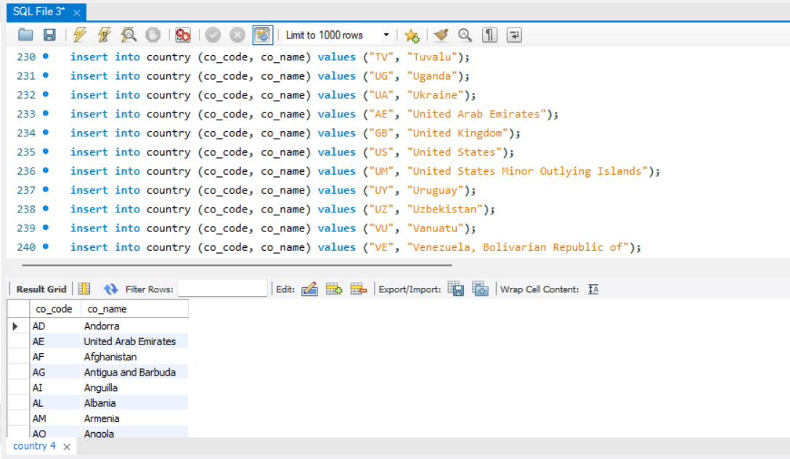

**Hands on 6**

**Find a country based on country code**

**OrmLearnApplication.java**

package com.cognizant.orm_learn;

import com.cognizant.orm_learn.model.Country;

import com.cognizant.orm_learn.service.CountryService;

import com.cognizant.orm_learn.service.exception.CountryNotFoundException;

import org.slf4j.Logger;

import org.slf4j.LoggerFactory;

import org.springframework.boot.SpringApplication;

import org.springframework.boot.autoconfigure.SpringBootApplication;

import org.springframework.context.ApplicationContext;

*@SpringBootApplication*

public class OrmLearnApplication {

private static final Logger ***LOGGER*** = LoggerFactory.*getLogger*(OrmLearnApplication.class);

private static CountryService *countryService*;

public static void main(String[] args) throws CountryNotFoundException {

ApplicationContext context = SpringApplication.*run*(OrmLearnApplication.class, args);

*countryService* = context.getBean(CountryService.class);

*getCountryTest*();

}

private static void getCountryTest() throws CountryNotFoundException {

***LOGGER***.info("Start");

Country country = *countryService*.findCountryByCode("IN");

***LOGGER***.debug("Country: {}", country);

***LOGGER***.info("End");

}

}

**CountryService.java**

package com.cognizant.orm_learn.service;

import com.cognizant.orm_learn.model.Country;

import com.cognizant.orm_learn.repository.CountryRepository;

import com.cognizant.orm_learn.service.exception.CountryNotFoundException;

import org.springframework.beans.factory.annotation.Autowired;

import org.springframework.stereotype.Service;

import org.springframework.transaction.annotation.Transactional;

import java.util.List;

import java.util.Optional;

*@Service*

public class CountryService {

*@Autowired*

private CountryRepository countryRepository;

*@Transactional*(readOnly = true)

public List<Country> getAllCountries() {

return countryRepository.findAll();

}

*@Transactional*

public void addCountry(Country country) {

countryRepository.save(country);

}

*@Transactional*

public void updateCountry(String code, String newName) throws CountryNotFoundException {

Optional<Country> result = countryRepository.findById(code);

if (!result.isPresent()) {

throw new CountryNotFoundException("Country with code " + code + " not found");

}

Country country = result.get();

country.setName(newName);

countryRepository.save(country);

}

*@Transactional*

public void deleteCountry(String code) throws CountryNotFoundException {

Optional<Country> result = countryRepository.findById(code);

if (!result.isPresent()) {

throw new CountryNotFoundException("Country with code " + code + " not found");

}

countryRepository.deleteById(code);

}

*@Transactional*(readOnly = true)

public List<Country> findCountriesByNameContaining(String partialName) {

return countryRepository.findByNameContainingIgnoreCase(partialName);

}

*@Transactional*

public Country findCountryByCode(String countryCode) throws CountryNotFoundException {

Optional<Country> result = countryRepository.findById(countryCode);

if (!result.isPresent()) {

throw new CountryNotFoundException("Country not found with code: " + countryCode);

}

return result.get();

}

}

**CountryNotFound.java**

package com.cognizant.orm_learn.service.exception;

public class CountryNotFoundException extends Exception {

public CountryNotFoundException(String message) {

super(message);

}

}

**OUTPUT:**

**Country Found:**

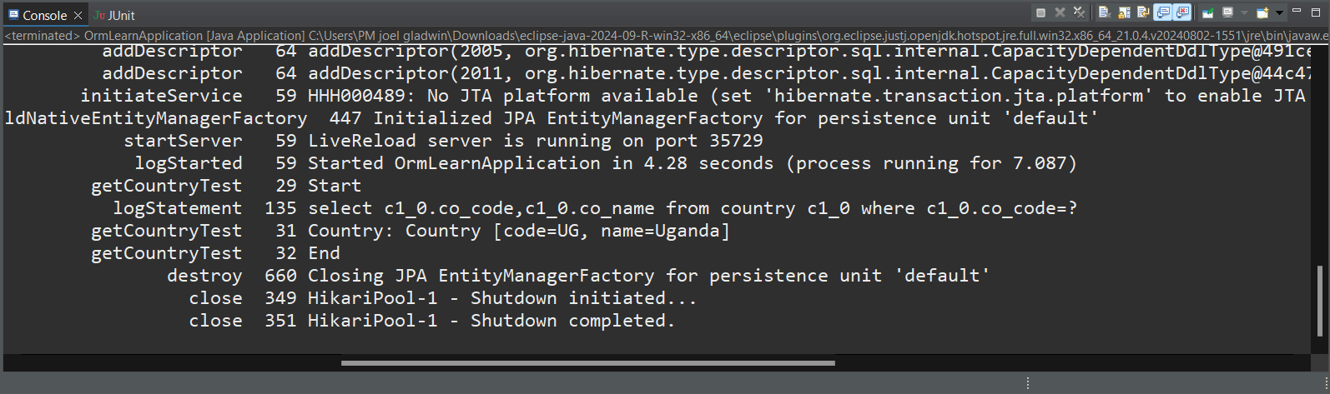

**Country Not Found Exception:**

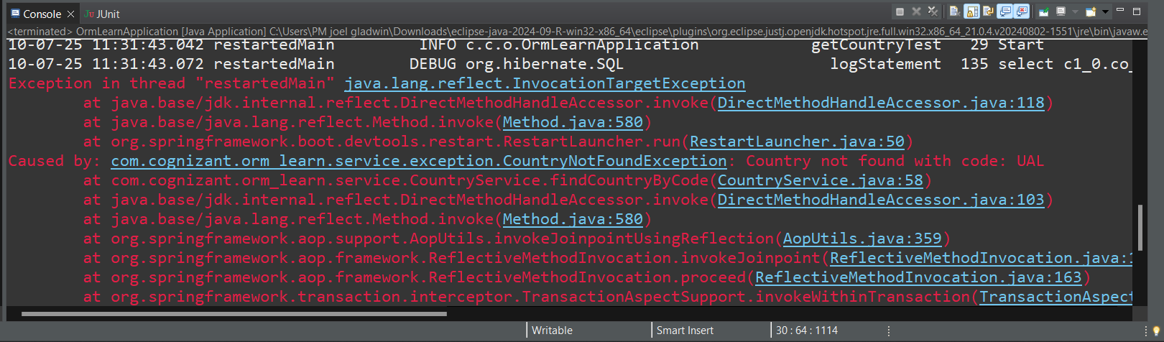

**Hands on 7**

**Add a new country** 

**OrmLearnApplication.java**

package com.cognizant.orm_learn;

import com.cognizant.orm_learn.model.Country;

import com.cognizant.orm_learn.service.CountryService;

import com.cognizant.orm_learn.service.exception.CountryNotFoundException;

import org.slf4j.Logger;

import org.slf4j.LoggerFactory;

import org.springframework.boot.SpringApplication;

import org.springframework.boot.autoconfigure.SpringBootApplication;

import org.springframework.context.ApplicationContext;

*@SpringBootApplication*

public class OrmLearnApplication {

private static final Logger ***LOGGER*** = LoggerFactory.*getLogger*(OrmLearnApplication.class);

private static CountryService *countryService*;

public static void main(String[] args) throws CountryNotFoundException {

ApplicationContext context = SpringApplication.*run*(OrmLearnApplication.class, args);

*countryService* = context.getBean(CountryService.class);

*getCountryTest*();

*testAddCountry*();

}

private static void getCountryTest() throws CountryNotFoundException {

***LOGGER***.info("Start");

Country country = *countryService*.findCountryByCode("IN");

***LOGGER***.debug("Country: {}", country);

***LOGGER***.info("End");

}

private static void testAddCountry() {

***LOGGER***.info("Start testAddCountry");

Country newCountry = new Country();

newCountry.setCode("JG");

newCountry.setName("JoelGladwin");

*countryService*.addCountry(newCountry);

try {

Country addedCountry = *countryService*.findCountryByCode("XY");

***LOGGER***.debug("Added Country: {}", addedCountry);

} catch (CountryNotFoundException e) {

***LOGGER***.error("Country not found after adding", e);

}

***LOGGER***.info("End testAddCountry");

}

}

**OUTPUT:**

**Before Adding new Country:**

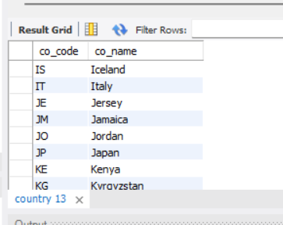

**After Adding new Country:**

